EQUIPMENT RENTAL MANAGEMENT
@CREATIVITY THINK (9483175986/7019689991)

ABSTRACT:
Equipment Rental Management is a web-based application designed to streamline the process of listing, booking, and managing equipment for rental businesses, offices, and laboratories. The platform provides automated booking workflows, payment tracking, status monitoring, and analytics dashboards for both users and administrators. Users can browse available equipment, make bookings, and monitor payment status, while administrators can manage inventory, track transactions, and generate operational insights. Developed with Django and Django Rest Framework for backend processes, and React with axios and recharts for client-side interactions, this system ensures efficiency, transparency, and real-time availability management..

INTRODUCTION OF THE PROJECT:
In many organizations, equipment rental and tracking are performed manually or through unorganized spreadsheets. This often leads to booking conflicts, data inaccuracies, and ineffective payment tracking. Equipment Rental Management addresses these challenges by offering a centralized, digital, and structured platform for handling equipment listings, bookings, payments, and analytics. With real-time updates, secure APIs, and an intuitive frontend, the system simplifies the workflow for both administrators and end users, ensuring transparency, accuracy, and operational efficiency..

PROJECT OBJECTIVES:

• Provide a centralized system for listing and renting equipment
• Enable users to search, view availability, and book equipment
• Track booking status and payment progress in real time
• Allow administrators to manage inventory, bookings, and payments
• Provide dashboards with charts for rental analytics
• Reduce manual errors and improve operational efficiency
• Offer secure and scalable backend APIs
• Support structured reporting and decision-making

PROBLEM OF THE STATEMENT:
Traditional methods of managing equipment rentals suffer from inefficiencies such as miscommunication, double-bookings, inaccurate payment tracking, and lack of real-time availability information. Manual processes also lack transparency, making it difficult to audit or generate performance insights. Equipment Rental Management solves these issues by providing a digital architecture where equipment data, booking history, payment records, and analytics are managed automatically, eliminating manual inconsistencies and improving workflow reliability..

MOTIVATION OF THE PROJECT:
• To digitalize equipment rental operations
• To reduce administrative workload and avoid double bookings
• To ensure accurate, transparent tracking of payments
• To provide easy access to availability and booking information
• To improve decision-making through dashboard analytics
• To offer a professional and user-friendly interface for rental businesses
• To enhance accountability and operational flow

BLOCK DAIGRAM OF PROJECT:

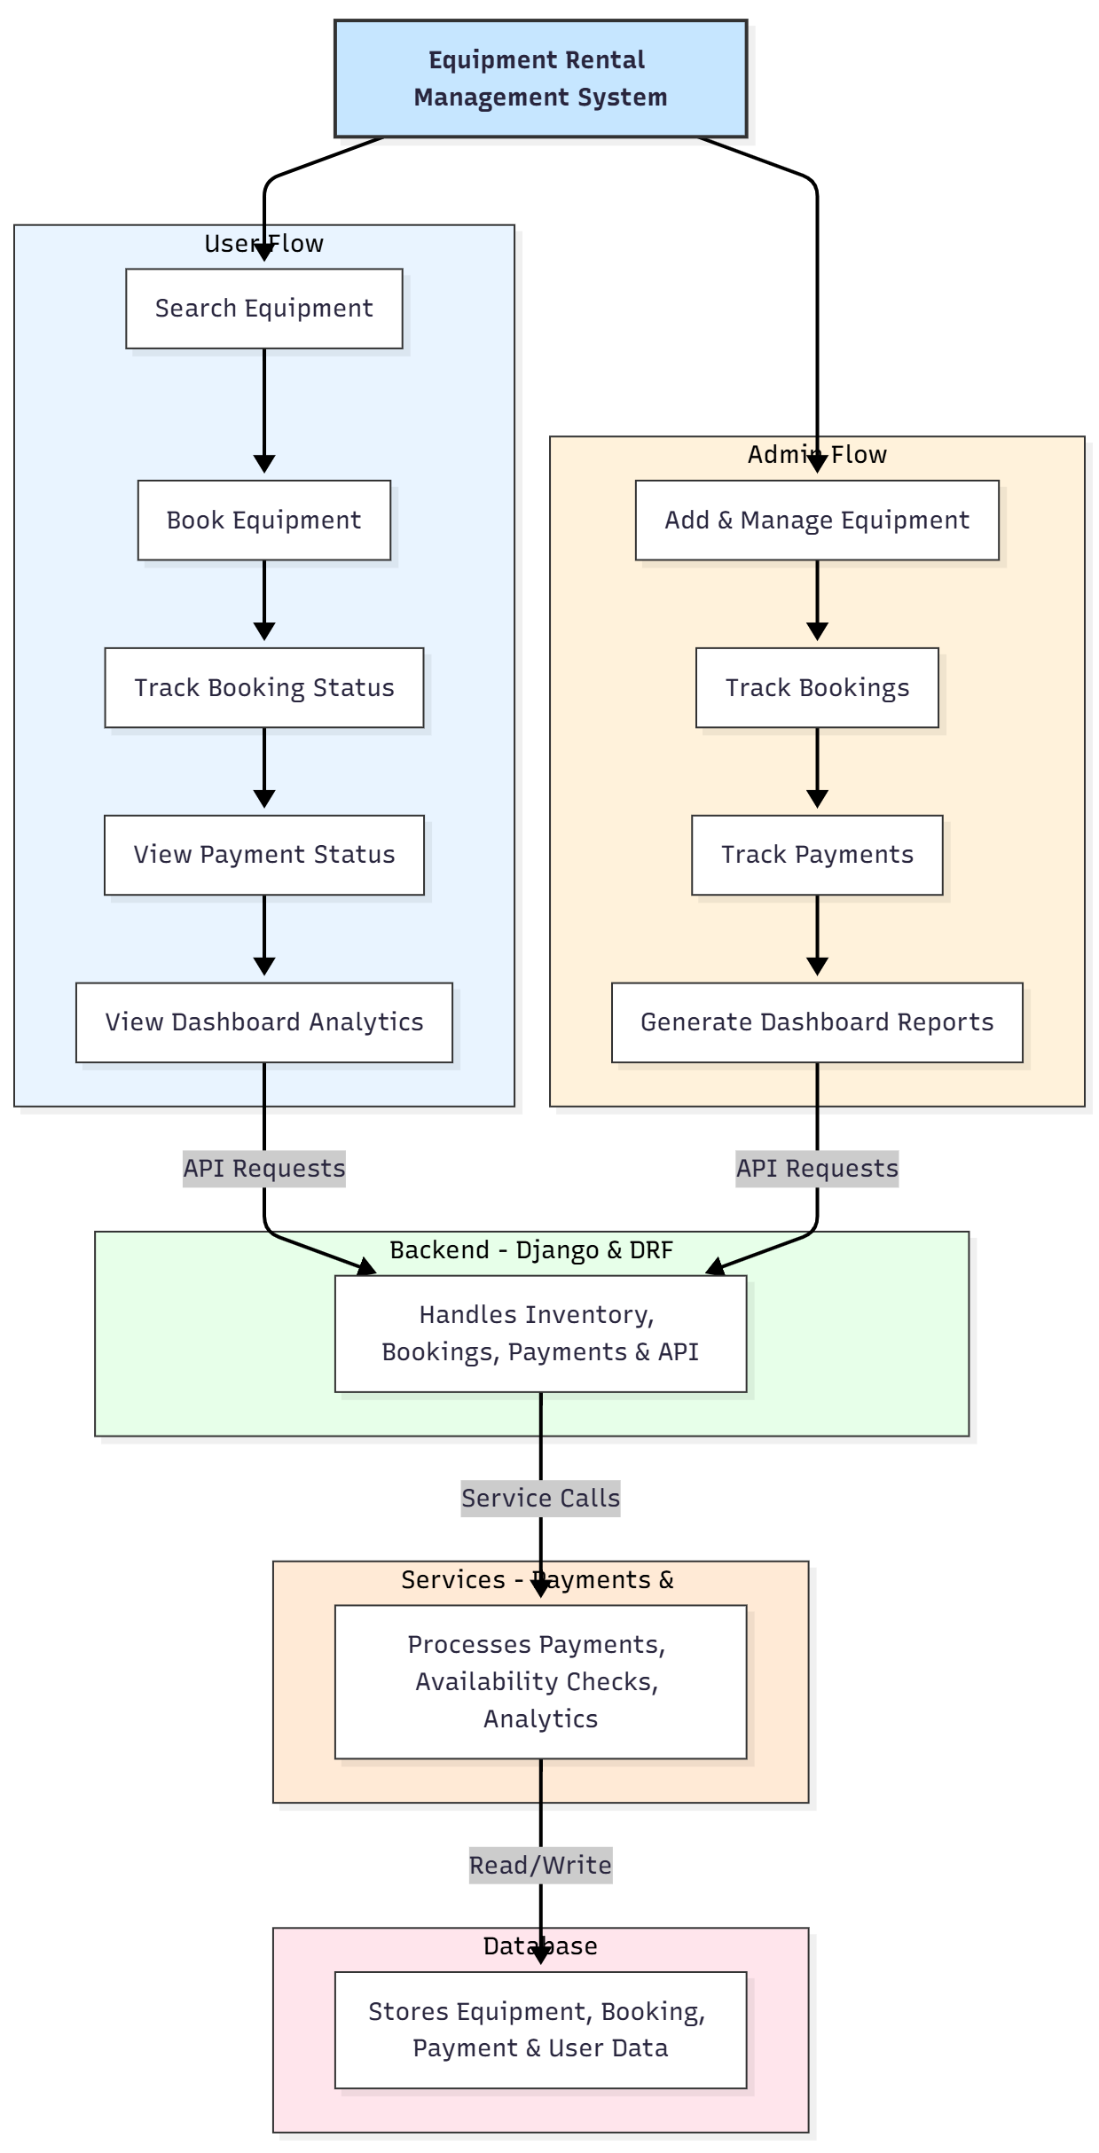

WORKING OF THE PROJECT:
The system begins with administrators adding equipment details such as name, category, availability, and rental charges. Users browse listed items, check availability, and place booking requests. The backend validates the booking, updates availability, and records payment details. Users can track the status of their bookings and payments through the dashboard. Administrators view all bookings, manage inventory, process payments, and oversee operational analytics. All interactions are logged and stored in the database, allowing seamless tracking and reporting. The analytics services generate charts and insights using structured data..

SOFTWARE REQUIREMENT:
- Backend:
  - Python 3.x
  - Django
  - Django REST Framework
  - SQLite/PostgreSQL
- Frontend:
  - Node.js and npm
  - React.js
  - Axios
- Development Tools:
  - Visual Studio Code
  - Postman (for testing APIs)
  - Git/GitHub (for version control)
- Server/Deployment (Optional):
  - Gunicorn, Nginx, or Heroku/AWS for hosting

ADVANTAGES OF THE PROJECT:

• Real-time equipment availability tracking
• Automated booking and payment workflow
• Reduces manual errors and spreadsheet dependency
• Transparent and accurate record-keeping
• Dashboard analytics for insights and performance metrics
• Easy management of inventory and transactions
• Improves operational speed and customer satisfaction
• Scalable for small and enterprise-level rental businesses

APPLICATIONS OF THE PROJECT:
• Equipment rental companies
• Corporate offices
• IT labs and technical departments
• Photography and videography rental shops
• Construction tool rental businesses
• Educational and research labs

REFERENCES:

- Django REST Framework Documentation — Django Software Foundation. Django Documentation. Available: https://docs.djangoproject.com/
- Django REST Framework. DRF Documentation. Available: https://www.django-rest-framework.org/
- React. React Official Documentation. Available: https://reactjs.org/docs/getting-started.html
- Redux. Redux Documentation. Available: https://redux.js.org/introduction/getting-started
- PostgreSQL Global Development Group. PostgreSQL Documentation. Available: https://www.postgresql.org/docs/
- MySQL. MySQL Reference Manual. Available: https://dev.mysql.com/doc/
- Git. Git Documentation. Available: https://git-scm.com/doc
- Node.js. Node.js Documentation. Available: https://nodejs.org/en/docs/
- Axios. Axios Documentation. Available: https://axios-http.com/docs/intro
- Socket.io Documentation – https://socket.io/docs/

